WHY ARE BUTTERFLIES FEELING SALTY?
Salt used to melt ice on winter roads can affect the development of butterflies.
By Josephine adoah DATE January 2015
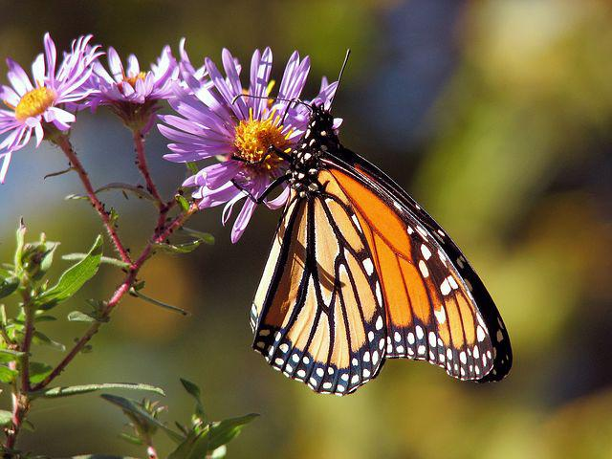
Sodium used to help make ice melt in winter can alter how the bodies of monarch butterflies develop.
Image from pixabay

Answer the following questions in full sentences:
- What is this news story about?
Salt used for gritting roads affects how butterflies develop in their cocoons.
- What two species of butterfly were studied?
Monarch butterflies and white cabbage butterflies.
- What effect does eating salt have on the butterflies?
Male caterpillars that had high salt levels in their diet developed larger muscles in their thorax and female butterflies emerged with larger eyes.

- Is it ethical to carry out experiments on animals like butterflies if they might die as a result?
Any experiment that is carried out on living organisms should have the benefits weighed against the costs of carrying it out.
This can also be a personal judgement.

- Write down the meanings of any words in bold in the article.
Contrast – when something is different
Conservationists – people who are concerned with environmental and wildlife protection
Ecologist – a scientist who studies how plants and animals interact with their habitat
Thorax – the part of an animal body between the neck and abdomen
Speculated – form a theory without evidence

